PREPARATION SHEET LAB 03
FIR Filter Implementation in MATLAB and in C
Team  (Group number + letter as chosen in Moodle) | Team members
Team  (Group number + letter as chosen in Moodle) | 1 | Emir Avni Sahin
1-1 | 2 | Efe Kardes
1-1 | 3

Please fill out the document electronically – including the yellow fields above – and upload it to Moodle once per team by the start of the lab event (no matter who uploads it, it will automatically be assigned to all members).
Please note that the complete assignment can be found in another document.
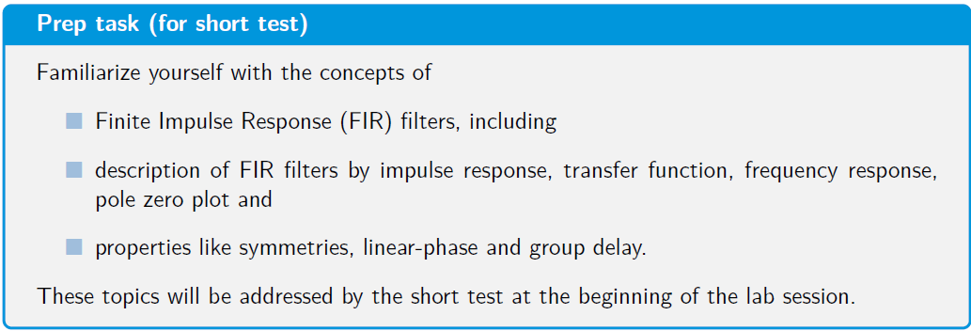
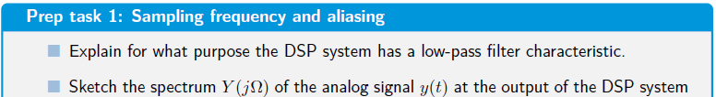

- Anti-Aliasing Filter (before ADC): It restricts the bandwidth of the incoming analog signal to below the Nyquist frequency (fs / 2). If frequencies higher than this enter the ADC, they alias into the baseband and irreversibly corrupt the digital signal.
- Reconstruction Filter (after DAC): Also known as an anti-imaging filter, it smooths out the "staircase" output from the digital-to-analog conversion by filtering out the high-frequency spectral images created by the zero-order hold process.

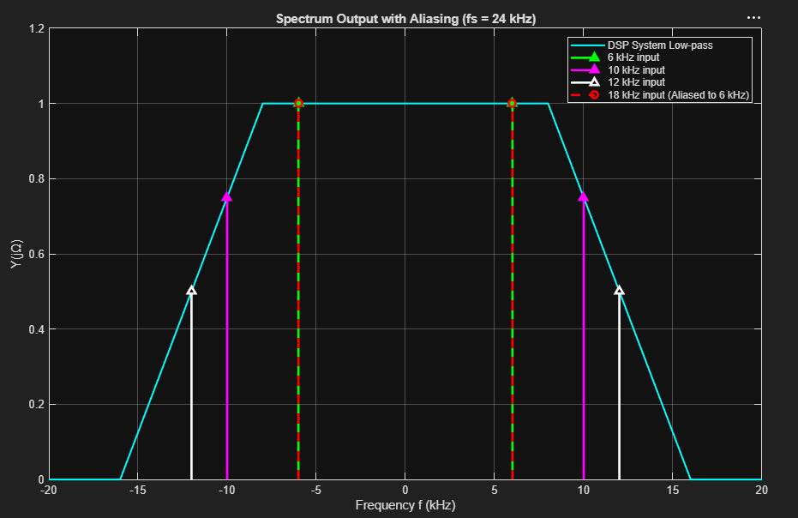

- Give the Matlab code here:
% 1. Specifications for Lowpass Filter
fs = 25000; % Sampling frequency in Hz (fs)
f_pass = 4500; % Passband edge frequency in Hz (where the filter starts cutting)
f_stop = 5000; % Stopband edge frequency in Hz (where the filter must reach maximum attenuation)
Rp_lin = 0.1; % Maximum passband ripple (given as a linear value, not in decibels)
As_dB = 40; % Minimum stopband attenuation (given in decibels)
dev_pass = Rp_lin; % Already linear, so we just pass it through
dev_stop = 10^(-As_dB / 20); % Formula to convert dB to linear magnitude
% 2. Design the Lowpass filter
f_edges = [f_pass f_stop]; % The transition band boundaries
amps = [1 0]; % Desired amplitude at those bands (1 = pass, 0 = stop)
devs = [dev_pass dev_stop]; % Maximum allowed error in those bands
[n, fo, ao, w] = firpmord(f_edges, amps, devs, fs); % Minimum filter order (n), normalized frequency (fo), amplitude (ao), weight (w).
if mod(n, 2) ~= 0
n = n + 1; % % If 'n' is odd, add 1 to force it to be even
end
b_fir_coe_LP = firpm(n, fo, ao, w); % optimization algorithm) to calculate the actual impulse response (coefficients).
% 3. Bandstop Filter via Frequency Transformation
b_fir_coe_BS = zeros(1, 2 * length(b_fir_coe_LP) - 1); % original length, minus 1
b_fir_coe_BS(1:2:end) = b_fir_coe_LP;
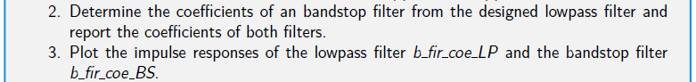
- Coefficients, impulse responses
LP Filter Coefficients->
Columns 1 through 10:
-0.0086 -0.0040 0.0065 0.0193 0.0229 0.0129 -0.0020 -0.0076 0.0004 0.0108
Columns 11 through 20:
0.0094 -0.0037 -0.0129 -0.0058 0.0103 0.0152 0.0005 -0.0172 -0.0149 0.0081
Columns 21 through 30:
0.0246 0.0109 -0.0210 -0.0315 -0.0005 0.0407 0.0372 -0.0236 -0.0789 -0.0409
Columns 31 through 40:
0.1119 0.2941 0.3755 0.2941 0.1119 -0.0409 -0.0789 -0.0236 0.0372 0.0407
Columns 41 through 50:
-0.0005 -0.0315 -0.0210 0.0109 0.0246 0.0081 -0.0149 -0.0172 0.0005 0.0152
Columns 51 through 60:
0.0103 -0.0058 -0.0129 -0.0037 0.0094 0.0108 0.0004 -0.0076 -0.0020 0.0129
Columns 61 through 65:
0.0229 0.0193 0.0065 -0.0040 -0.0086
Band stop Filter Coefficients:
Columns 1 through 10
-0.0086 0 -0.0040 0 0.0065 0 0.0193 0 0.0229 0
Columns 11 through 20
0.0129 0 -0.0020 0 -0.0076 0 0.0004 0 0.0108 0
Columns 21 through 30
0.0094 0 -0.0037 0 -0.0129 0 -0.0058 0 0.0103 0
Columns 31 through 40
0.0152 0 0.0005 0 -0.0172 0 -0.0149 0 0.0081 0
Columns 41 through 50
0.0246 0 0.0109 0 -0.0210 0 -0.0315 0 -0.0005 0
Columns 51 through 60:
0.0407 0 0.0372 0 -0.0236 0 -0.0789 0 -0.0409 0
Columns 61 through 70:
0.1119 0 0.2941 0 0.3755 0 0.2941 0 0.1119 0
Columns 71 through 80:
-0.0409 0 -0.0789 0 -0.0236 0 0.0372 0 0.0407 0
Columns 81 through 90:
-0.0005 0 -0.0315 0 -0.0210 0 0.0109 0 0.0246 0
Columns 91 through 100:
0.0081 0 -0.0149 0 -0.0172 0 0.0005 0 0.0152 0
Columns 101 through 110: 0.0103 0 -0.0058 0 -0.0129 0 -0.0037 0 0.0094 0
Columns 111 through 120:
0.0108 0 0.0004 0 -0.0076 0 -0.0020 0 0.0129 0
Columns 121 through 129: 0.0229 0 0.0193 0 0.0065 0 -0.0040 0 -0.0086
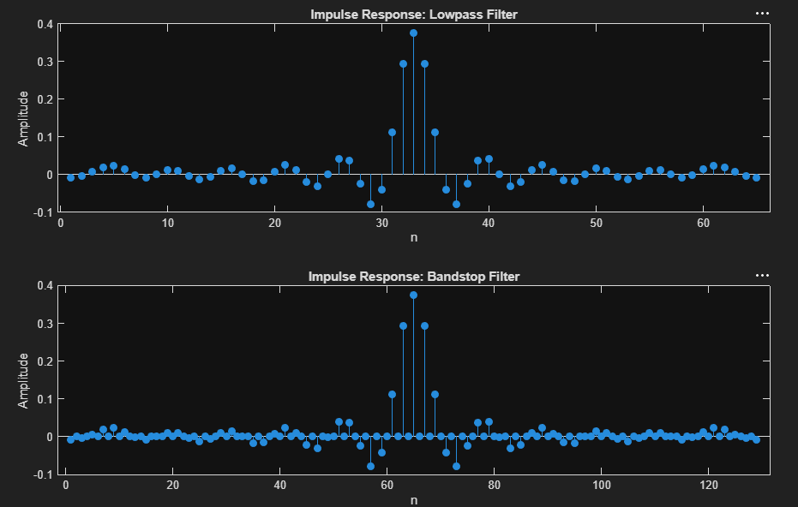

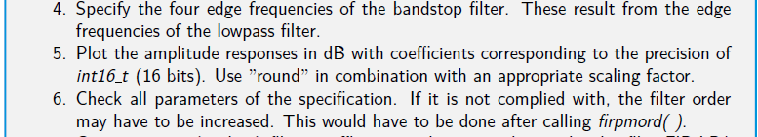
- Edge frequencies (part 4)
Lower passband edge: 4500 / 2 = 2250 Hz
Lower stopband edge: 5000 / 2 = 2500 Hz
Upper stopband edge: 12500 - 2500= 10000 Hz
Upper passband edge: 12500 - 2250 = 10250 Hz

- Plot the amplitude responses (using dB-scale) with coefficients quantized to 16 bit.
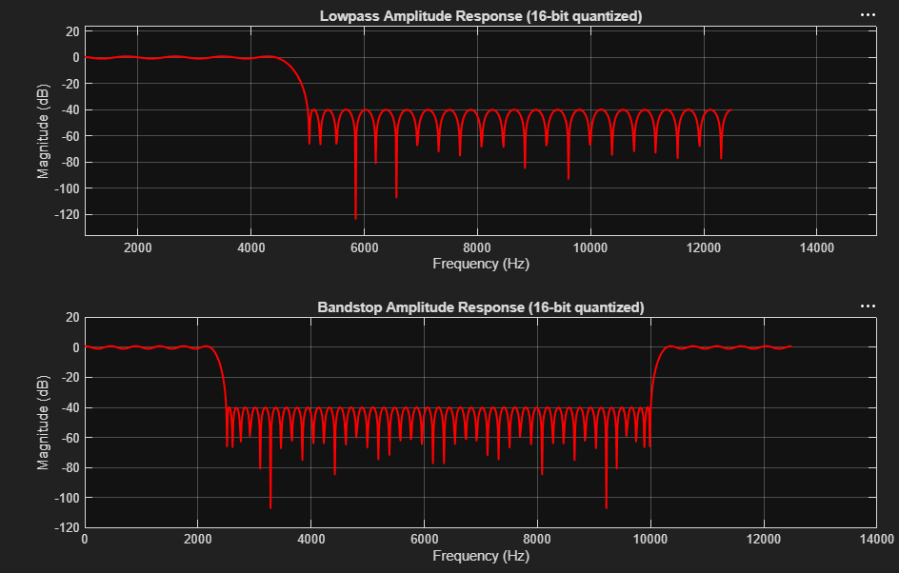
- Check if corner frequencies of the filter, pass band ripple and stop band attenuation are within specification limits. If not met, increase the FIR filter order until the specification is met.

All parameters of the specification are met with the 16-bit quantized coefficients.

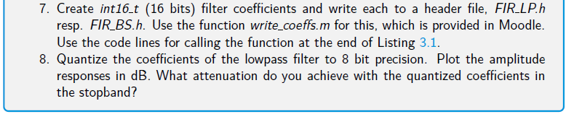
- Content of header files.
const int16_t asFirCoeLP[65] = {-283, -130, 212, 631, 752, 423, -67, -250, 13, 354, 307, -121, -422, -189, 338, 497, 18, -565, -487, 266, 806, 356, -688, -1032, -17, 1335, 1218, -772, -2586, -1341, 3667, 9637, 12305, 9637, 3667, -1341, -2586, -772, 1218, 1335, -17, -1032, -688, 356, 806, 266, -487, -565, 18, 497, 338, -189, -422, -121, 307, 354, 13, -250, -67, 423, 752, 631, 212, -130, -283};
- Measured attenuation in stop band: ~26dB
- 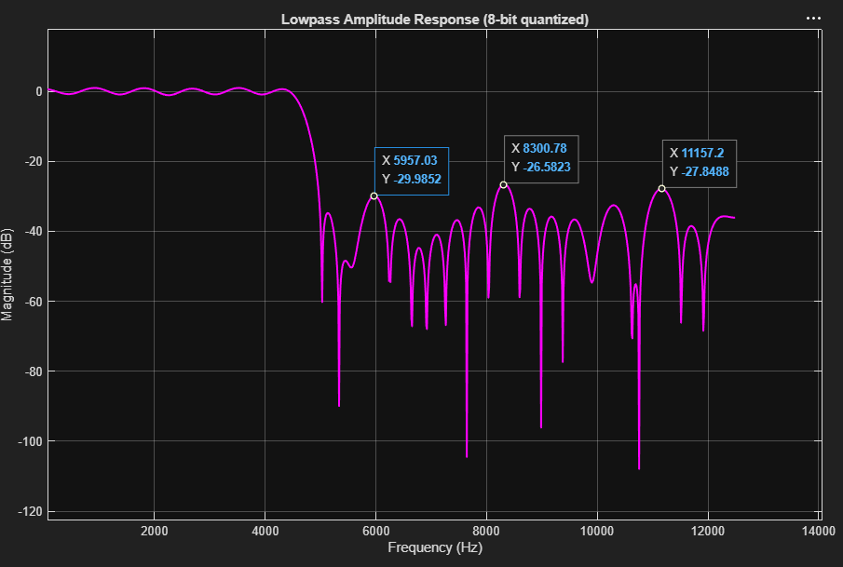
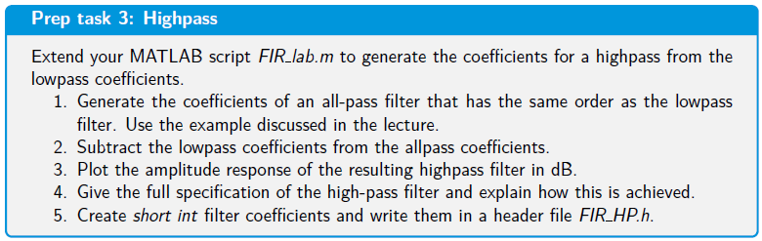
- MATLAB code for part 1&2:
% 1. Generate All-pass coefficients (Delay M)
M = n / 2; % Center delay index
allpass = zeros(1, length(b_fir_coe_LP));
allpass(M + 1) = 1;
% 2. Subtract lowpass from allpass to create Highpass
b_fir_coe_HP = allpass - b_fir_coe_LP;
Amplitude response plot (part 3) 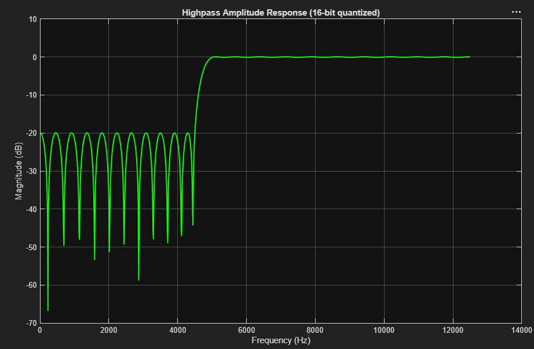
- Spec high pass filter (part 4):
The highpass filter is generated by spectral inversion:
H_HP(z) = z^(-M) - H_LP(z)
The stopband edge of the highpass is 4500 Hz.
The passband edge of the highpass is 5000 Hz
The highpass stopband attenuation is determined by the lowpass passband ripple:
A_s,HP = -20 log10(0.1) = 20 dB
The highpass passband ripple is determined by the lowpass stopband error:
delta_p,HP = 10^(-40/20) = 0.01

Therefore, the resulting highpass has approximately:
- stopband edge: 4500 Hz
- passband edge: 5000 Hz
- stopband attenuation: 20 dB

- passband ripple: 0.01 linear, approximately ±0.087 dB
- Content of header file (part 5):
- const int16_t asFirCoeHP[65] = {283, 130, -212, -631, -752, -423, 67, 250, -13, -354, -307, 121, 422, 189, -338, -497, -18, 565, 487, -266, -806, -356, 688, 1032, 17, -1335, -1218, 772, 2586, 1341, -3667, -9637, 20462, -9637, -3667, 1341, 2586, 772, -1218, -1335, 17, 1032, 688, -356, -806, -266, 487, 565, -18, -497, -338, 189, 422, 121, -307, -354, -13, 250, 67, -423, -752, -631, -212, 130, 283};

